Mobile Network - Cell Towers
# Source: Chatgpt (GPT-5-Mini) at [1/23/2026]
A cell tower (also called a cell site or cellular base station) is a tall structure with antenna equipment that allows mobile devices like smartphones to connect to the cellular network. Cell towers are the backbone of mobile communication, enabling calls, texts, and mobile internet.

Cell Towers photo
# Source: Windows ScreenShots at [1/23/2026]
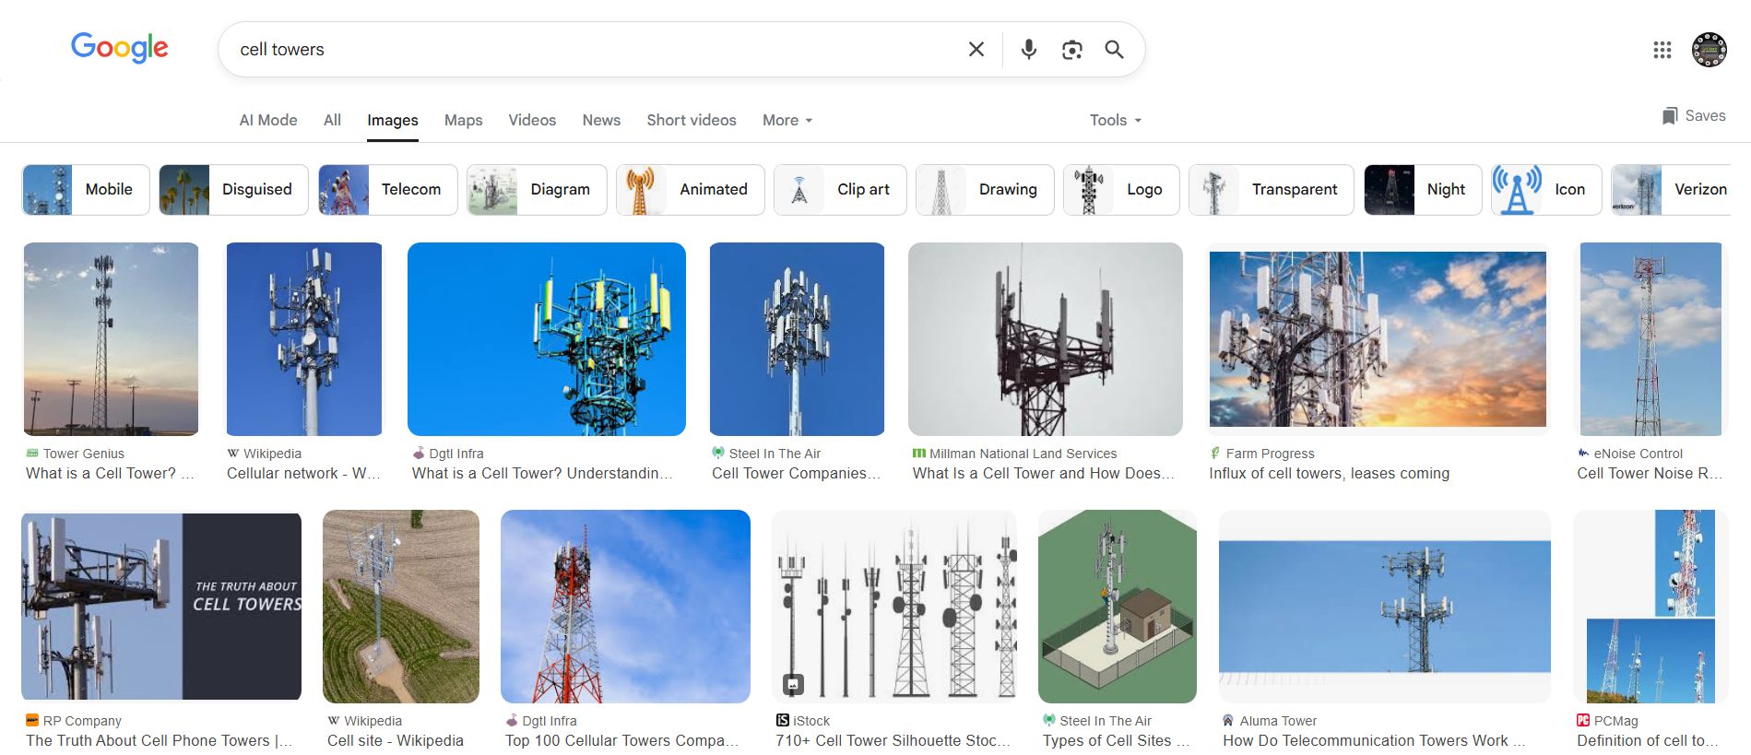

📡 What Do Cell Towers Do?
# Source: Chatgpt (GPT-5-Mini) at [1/23/2026]
Cell towers:
- Transmit and receive signals from mobile phones.
- Connect those signals to the cellular network (3G, 4G, 5G).
- Route calls and data through telecom infrastructure (like backhaul fiber or microwave links).
- Divide coverage areas into "cells" to serve multiple users efficiently.

🔑 Key Components of a Cell Tower:
# Source: Chatgpt (GPT-5-Mini) at [1/23/2026]
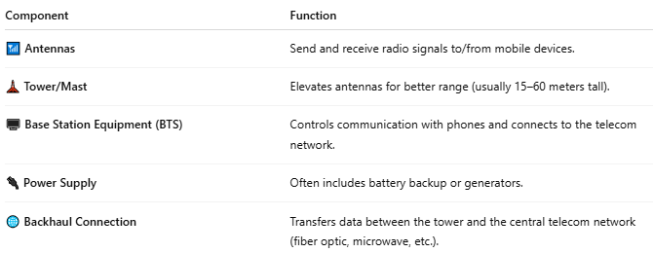

Component | Function
📶 Antennas | Send and receive radio signals to/from mobile devices.
🗼 Tower/Mast | Elevates antennas for better range (usually 15–60 meters tall).
🖥️ Base Station Equipment (BTS) | Controls communication with phones and connects to the telecom network.
🔌 Power Supply | Often includes battery backup or generators.
🌐 Backhaul Connection | Transfers data between the tower and the central telecom network (fiber optic, microwave, etc.).

🧠 How It Works (Simplified):
# Source: Chatgpt (GPT-5-Mini) at [1/23/2026]

📱 Your phone ↔️ 📡 Nearby Cell Tower ↔️ 🌐 Mobile Network ↔️ ☎️ Other phones or Internet

- As you move, your phone automatically switches to the nearest tower.
- Towers use different frequencies and technologies (2G, 3G, 4G LTE, 5G).

📍 Why Cell Towers Are Important:
# Source: Chatgpt (GPT-5-Mini) at [1/23/2026]
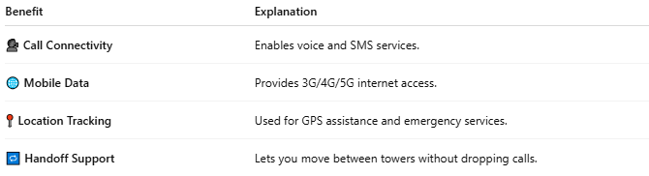

Benefit | Explanation
🗣️ Call Connectivity | Enables voice and SMS services.
🌐 Mobile Data | Provides 3G/4G/5G internet access.
📍 Location Tracking | Used for GPS assistance and emergency services.
🔁 Handoff Support | Lets you move between towers without dropping calls.

📖 Summary:
# Source: Chatgpt (GPT-5-Mini) at [1/23/2026]
A cell tower is a critical part of mobile networks, acting as a relay between your phone and the internet or other phones. It ensures that mobile users stay connected wirelessly, wherever they are.

